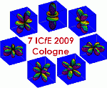
Terrae Rarae 2009
Proceedings of the 7th International Conference on f Elements, ICfE-7 ■ G. Meyer, editor.
August 23-27, 2009, Cologne, Germany

Rare-Earth and Transition Metal
Solid State and Coordination Chemistry

Gerd Meyer*

Universität zu Köln, Department Chemie, Greinstraße 6, D-50939 Köln, Germany

Abstract. The research programme at the Chair of Inorganic Chemistry I at the Department of Chemistry of the Universität zu Köln is reviewed briefly.

Keywords: Rare-Earth Elements; Transition Metals; Solid State Chemistry; Coordination Chemistry

Introduction

Transition (d block) and rare-earth (f block) metal halide chemistry is rich of oxidation states. In solid state chemistry, such oxidations states are of special interest that are lower than the respective group number.
Elaborate synthetic routes have been developed to explore the respective systems and to grow crystals for structure determination and to prepare pure samples for further characterization.
Coordination chemistry of a number of transition metal and rare-earth metals takes closed-shell ions or such with high magnetic moments as cetral ions and O- or N-donor ligands into accunt.

The Oxidation of Metals with Liebig Acids

Except for Wöhler’s Metallothermic Reduction a second synthetic route has been extraordinarily prolific throughout the years, the oxidation of non-noble metals with Liebig acids. These are all compounds with an acid hydrogen atom. There is a large variety of organic compounds with HO– or HN– functions with acid constants that allow for substitution of the hydrogen atom by a metal atom.
We have especially explored carboxylic acids yielding a large variety of new simple and complex salts, mostly coordination polymers. These include alkanoates as the isotypic propionates M(OPr)₂ (M = Mn, Fe; Fig. 6) as well as benzoates like Mn₁₉(OBz)₃₈(HOBz)₂, anhydrous acetates like Nd(OAc)₃ or the complicated [Eu₂(OAc)₆(HOAc)₂- (H₂O)₂](HOAc)₄ or heterobimetallic complexes as [Dy₂Co(OAc)₄(H₂O)₂](HOAc)₂.
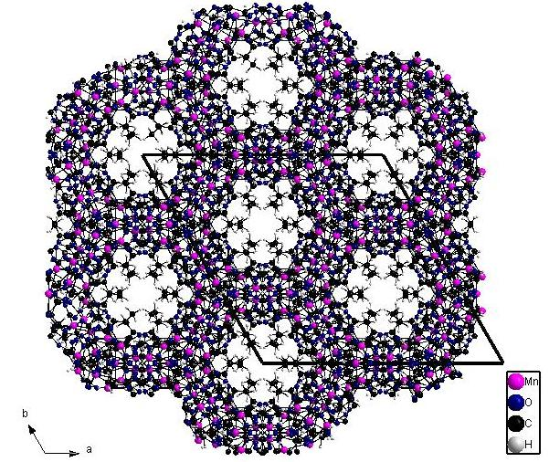

Figure 6: A view down the channels of the proprionates M(OPr)₂ (M = Mn, Fe).

Experimental Section

Synthesis. Starting materials were either purchased from usual commercial sources or made in the laboratory. Moisture and/or air-sensitive compounds were handled in nitrogen or argon filled dry boxes (Mbraun, Garching, Germany).

Crystal structures. Single crystals were selected under a microscope and sealed in thin-walled glass capillaries. Their quality was checked on a single-crystal X-ray diffractometer (Stoe Image Plate Diffraction System, IPDS I or II) and a complete intensity data set was collected using graphite-monochromated Mo-K_{α} radiation. The data were corrected for Lorentz and polarization effects. A numerical absorption correction based on crystal-shape optimization was applied for all data. The programs used are Stoe’s X-Area, including X-RED and X-Shape for data reduction and absorption correction, and the WinGX suite of programs, including SIR-92 and SHELXL-97 for structure solution and refinement. The last refinement cycles included atomic positions for all the atoms, anisotropic thermal parameters for all the non-hydrogen atoms and isotropic thermal parameters for all of the hydrogen atoms. Crystallographic data for the respective structure have been deposited with the Cambridge Crystallographic Data Centre or at the Fachinformationszentrum Karslruhe.
Crystal data for [Gd(OH)(H₂O)(b18c6)]-I(I₃)CH₃CN: C₁₈H₃₀NO₈GdI₄, 1053.28 g mol⁻¹; diffractometer IPDS-II, T = 170(2) K; 2θ_{max} = 54.8°; 0° ≤ ω ≤ 180°, ϕ = 0°, 0° ≤ ω ≤ 180°, ϕ = 90°, Δω = 2°, 180 images; -14 ≤ h ≤ 15, -24 ≤ k ≤ 24, -15 ≤ l ≤ 15; ρ_{calc} = 2.428 g cm⁻³; 37766 measured reflections of which 6263 were symmetrically independent; R_{int} = 0.1524; F(000) = 1940; μ = 6.626 mm⁻¹. Monoclinic, P2₁/a (no. 14), a = 1233.8(1), b = 1925.0(2), c = 1252.3(1) pm, β = 104.38(1)°, V = 2881.2(5) 10⁶·pm³, Z = 4; R values: R₁/wR₂ for 4516 reflections with [I₀>2σ(I₀)]: 0.0542 / 0.1262, for all data: 0.0739 / 0.1371; S_{all} = 1.027.

Acknowledgements.

This work has been supported by ....

G. Meyer, Z. Anorg. Allg. Chem. 2008, 634, 201-222.
S. Gomez Torres, Dissertation, Universität zu Köln, 2007; Th. Bierke, unpublished research, 2008.
X-Shape 1.06, Crystal Optimisation for Numerical Absorption Correction (C), Stoe & Cie GmbH, Darmstadt, 1999.
X-Area 1.16, Stoe & Cie GmbH, Darmstadt, 2003.
X-RED 1.22, Stoe Data Reduction Program (C), Stoe & Cie GmbH, Darmstadt, 2001.
L. J. Farrugia, J. Appl. Crystallogr. 1999, 32, 837.
A. Altomare, G. Cascarano, C. Giacovazzo, J. Appl. Crystallogr. 1993, 26, 343.
G. M. Sheldrick, SHELXL-97; Programs for Crystal Structure Analysis, Universität Göttingen, 1997.

